**OOJ LAB RECORD**

**LAB PROGRAM 6**

**Create a package CIE which has two classes- Student and Internals. The class Personal has members like usn, name, sem. The class internals has an array that stores the internal marks scored in five courses of the current semester of the student. Create another package SEE which has the class External which is a derived class of Student. This class has an array that stores the SEE marks scored in five courses of the current semester of the student. Import the two packages in a file that declares the final marks of n students in all five courses.**

|  |
| --- |
|  |

**In CIE package, Student.java**

package CIE;

public class Student

{

public String usn;

public String name;

public int sem;

public Student(String usn, String name, int sem)

{

this.usn = usn;

this.name = name;

this.sem = sem;

}

}

**In CIE package, Internals.java**

package CIE;

import java.util.Scanner;

public class Internals extends Student

{

Scanner in = new Scanner(System.in);

public int[] cie = new int[5];

public Internals(String usn, String name, int sem)

{

super(usn,name,sem);

}

public void get_data()

{

for(int i=0;i<5;i++)

{

System.out.print("Enter CIE marks of the student in Subject " + (i+1) + " (out of 50) : ");

cie[i] = in.nextInt();

}

}

}

**In SEE package, External.java**

package SEE;

import java.util.Scanner;

public class External extends CIE.Student

{

public External(String usn, String name, int sem)

{

super(usn,name,sem);

}

Scanner in = new Scanner(System.in);

public int[] see = new int[5];

public void get_data()

{

for(int i=0;i<5;i++)

{

System.out.print("Enter SEE marks of the student in Subject " + (i+1) + " (out of 100) : ");

see[i] = in.nextInt();

}

}

}

**In default package, final_marks.java**

import CIE.*;

import SEE.*;

import java.util.Scanner;

class final_marks

{

public static void main(String args[])

{

Scanner in = new Scanner(System.in);

System.out.print("Enter the number of students : ");

int n = in.nextInt();

CIE.Internals obj[] = new CIE.Internals[5];

SEE.External obj1[] = new SEE.External[5];

int total=0;

for(int i=0;i<n;i++)

{

System.out.println("\nEnter details of Student " + (i+1) + " :");

System.out.print("USN : ");

String usn = in.next();

System.out.print("Name : ");

String name = in.next();

System.out.print("Semester : ");

int sem = in.nextInt();

obj[i] = new CIE.Internals(usn,name,sem);

obj[i].get_data();

obj1[i] = new SEE.External(usn,name,sem);

obj1[i].get_data();

}

for(int i=0;i<n;i++)

{

System.out.println("\nTOTAL MARKS OF STUDENT " + (i+1) + " (out of 100) in :");

for(int j=0;j<5;j++)

{

total = (obj[i].cie[j]) + ((obj1[i].see[j])/2);

System.out.println("Subject " + (j+1) + " : " + total);

}

}

}

}

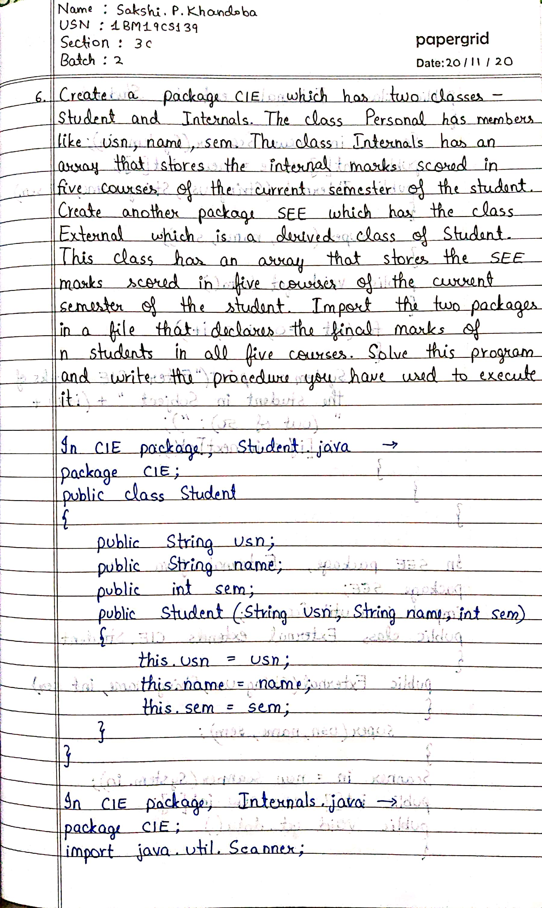

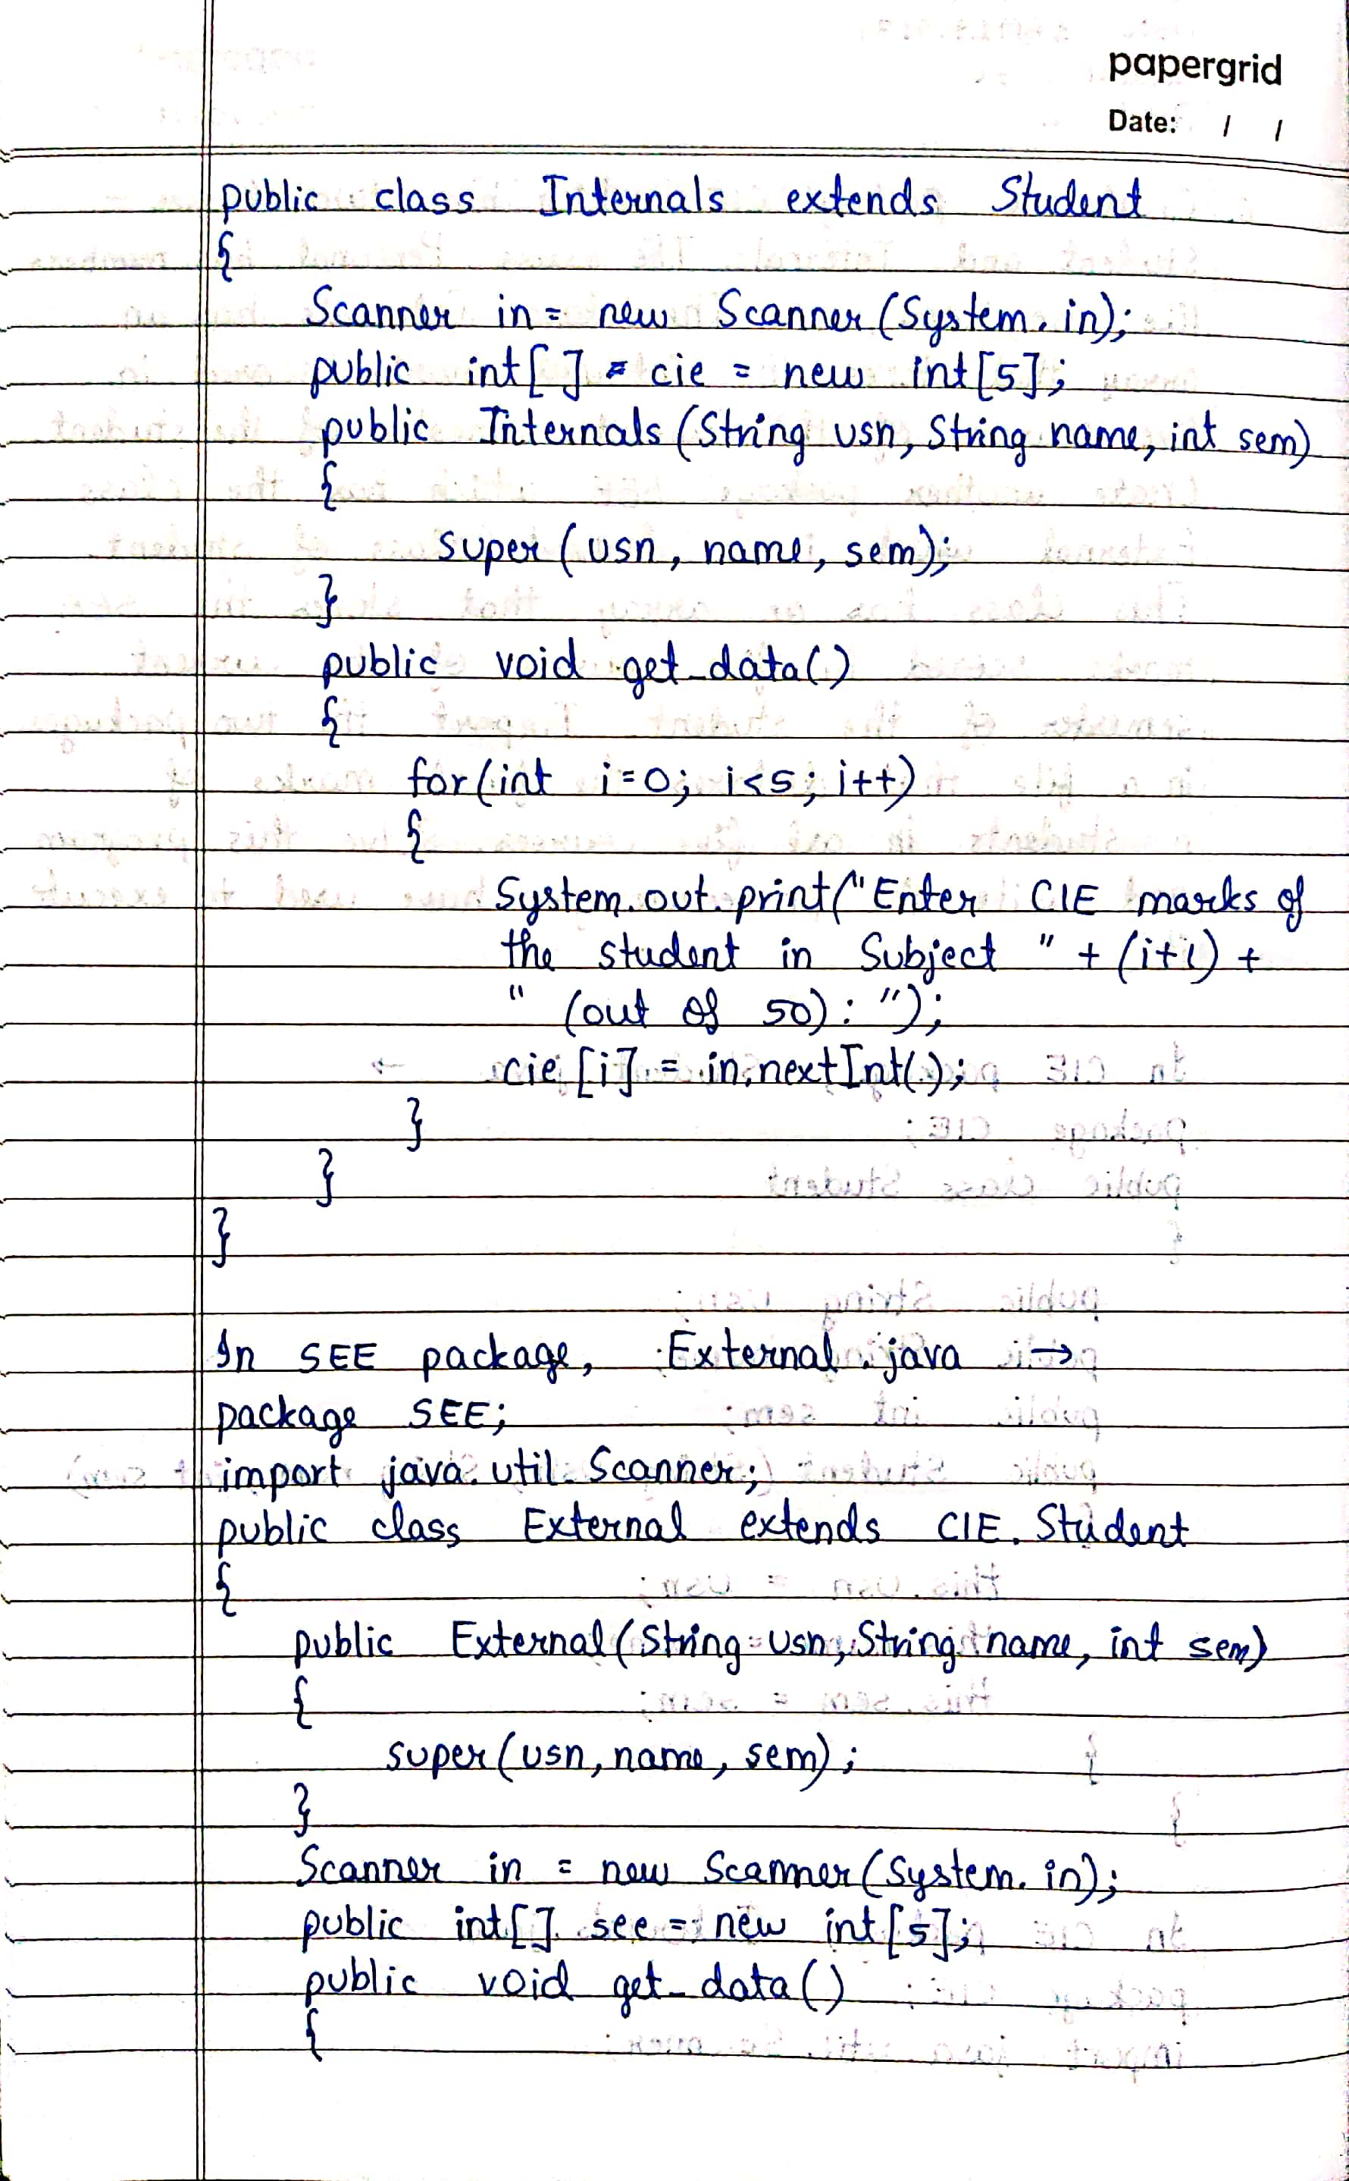

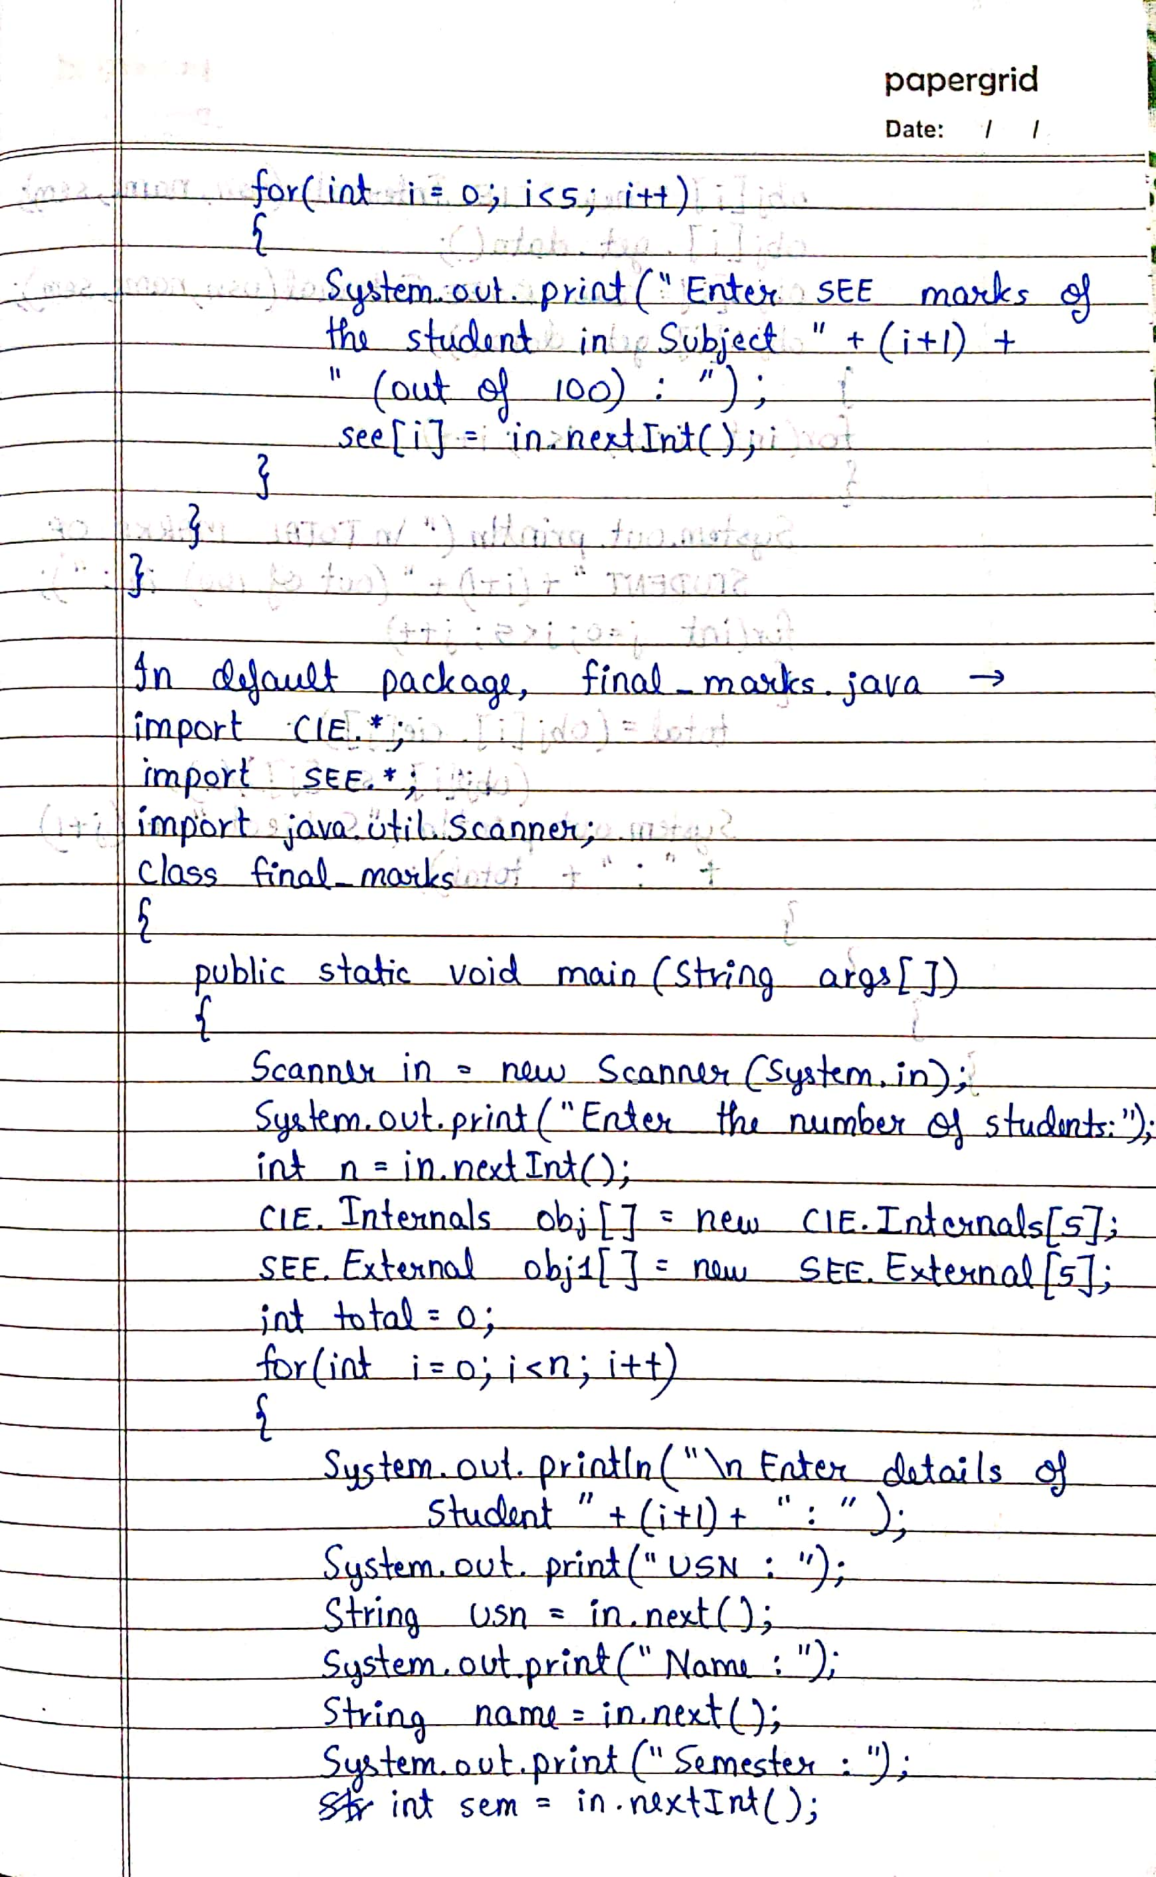

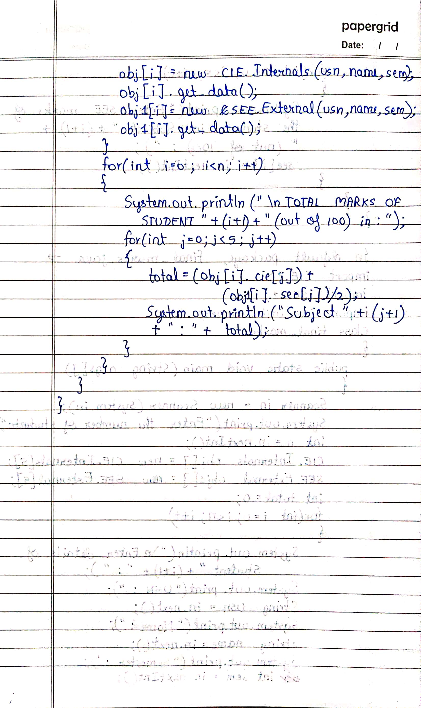

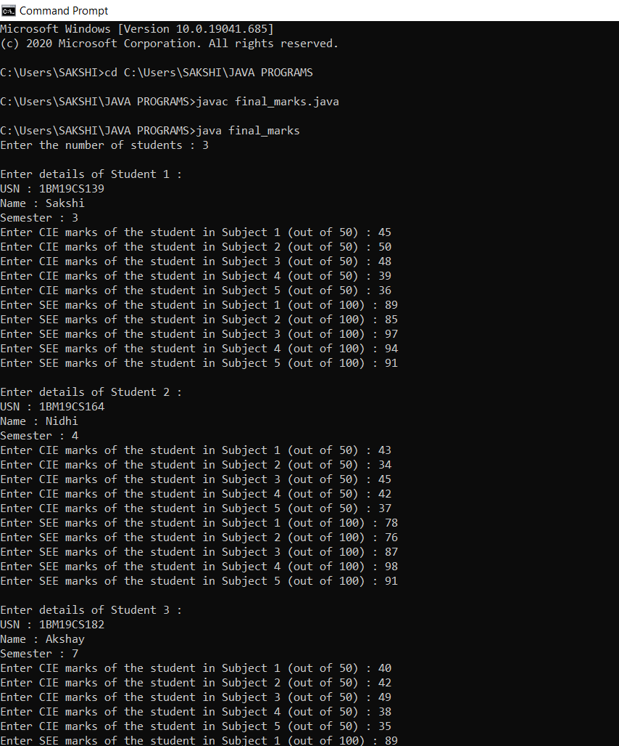

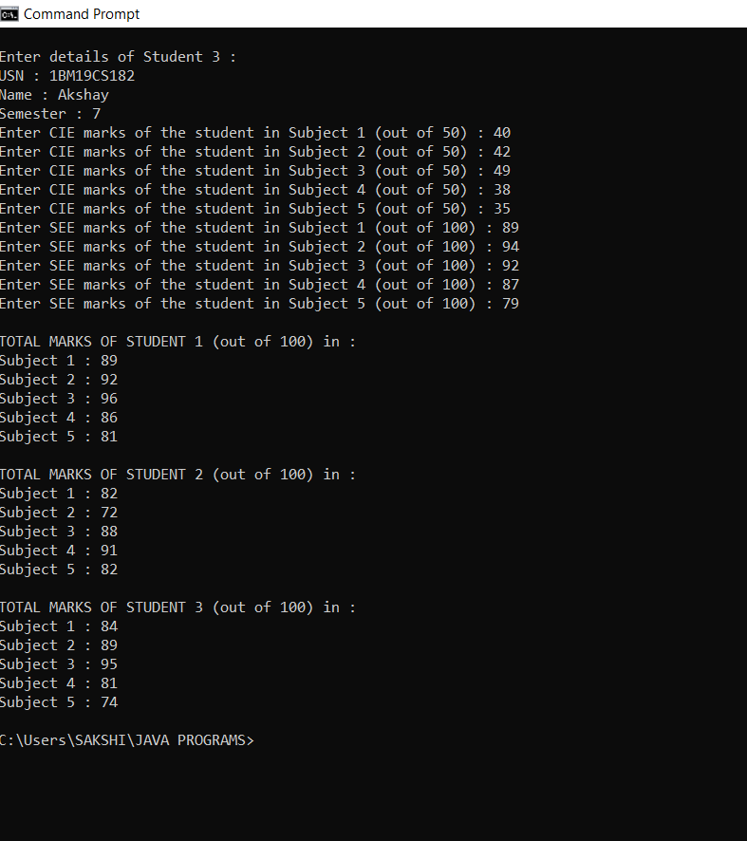

**LAB PROGRAM 7**

**Write a program to demonstrate generics with multiple object parameters.**

class TwoGen<T,V>

{

T obj1;

V obj2;

TwoGen(T ob1, V ob2)

{

obj1 = ob1;

obj2 = ob2;

}

void showTypes()

{

System.out.println("\nType of T is " + obj1.getClass().getName());

System.out.println("Type of V is " + obj2.getClass().getName());

}

T getobj1()

{

return obj1;

}

V getobj2()

{

return obj2;

}

}

class Generics

{

public static void main(String args[])

{

TwoGen<Integer, String> object1 = new TwoGen<Integer, String>(29, "Generics");

object1.showTypes();

int i = object1.getobj1();

System.out.println("Value of type T: " + i);

String str = object1.getobj2();

System.out.println("Value of type V: " + str);

TwoGen<String, Double> object2 = new TwoGen<String, Double>("This is generics.", 27.8348);

object2.showTypes();

String str1 = object2.getobj1();

System.out.println("Value of type T: " + str1);

double j = object2.getobj2();

System.out.println("Value of type V: " + j);

}

}

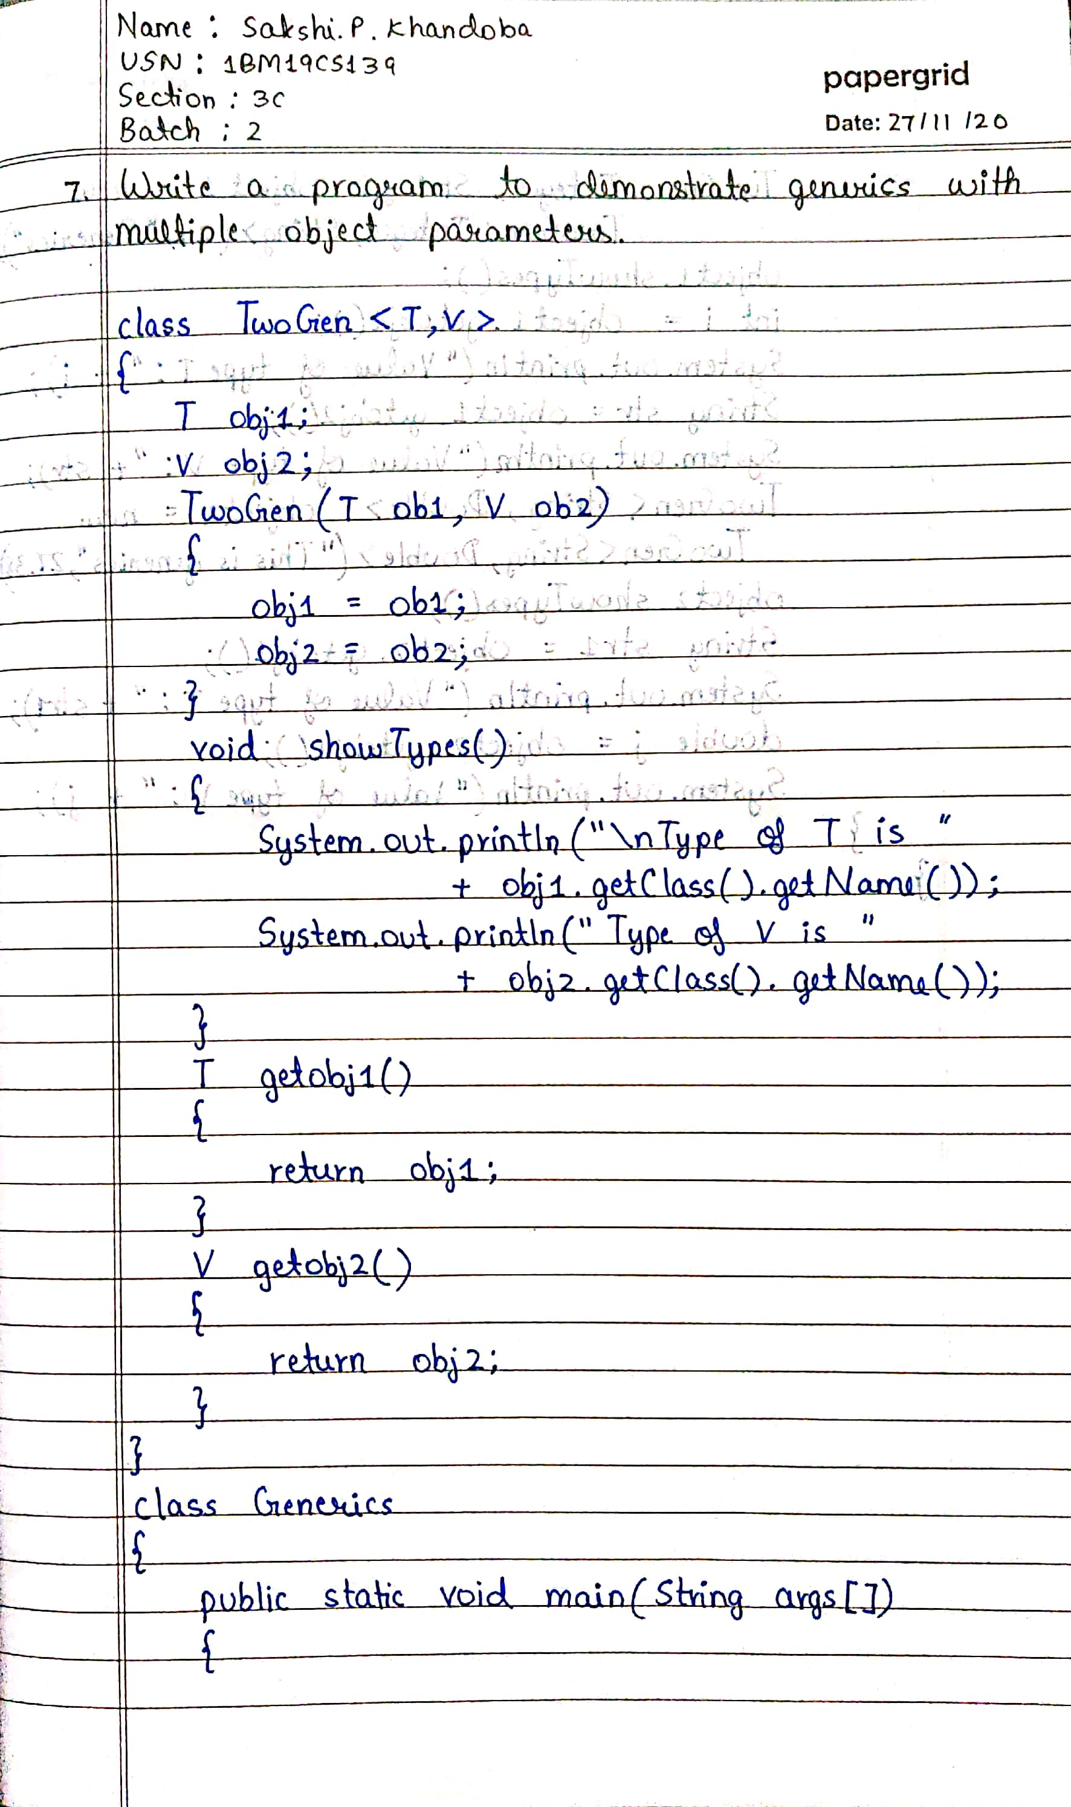

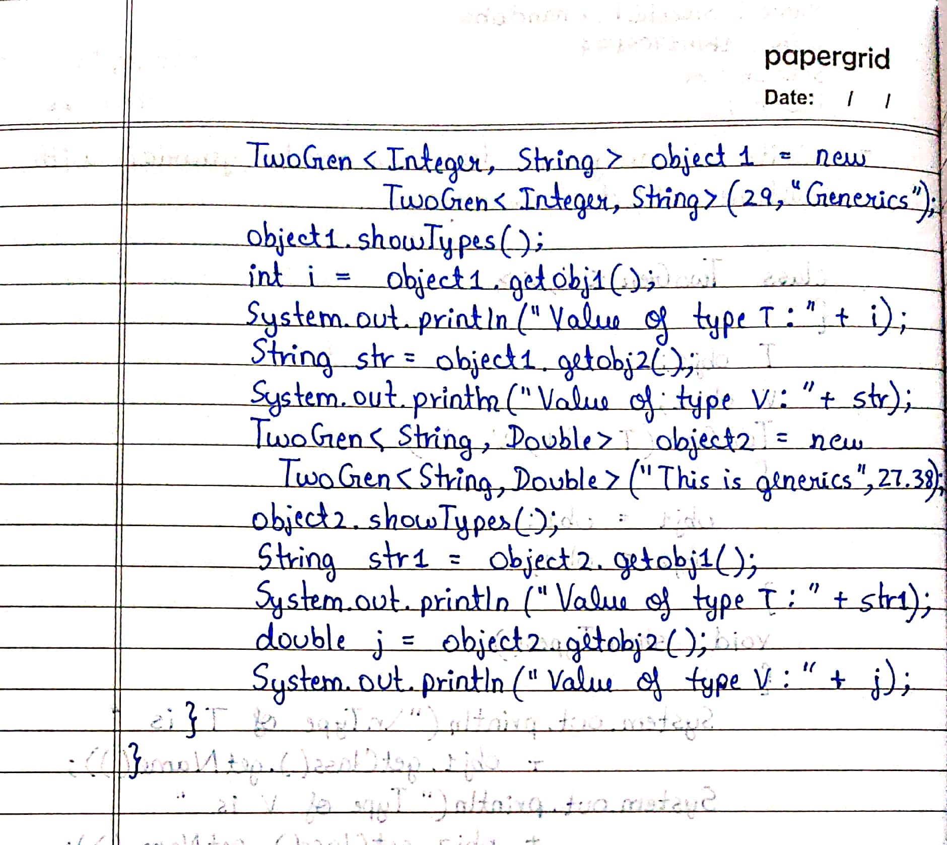

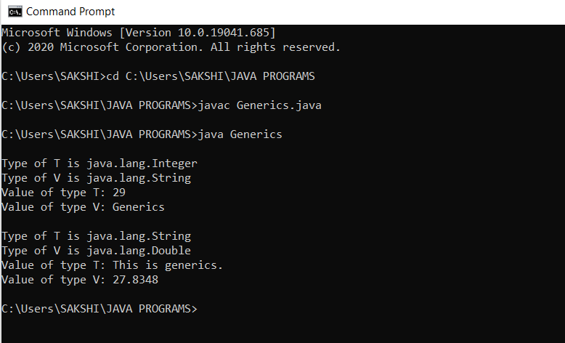

**LAB PROGRAM 8**

**Write a program that demonstrates handling of exceptions in inheritance tree. Create a base class called “Father” and derived class called “Son” which extends the base class. In Father class, implement a constructor which takes the age and throws the exception NegativeAge( ) when the input age<0. In Son class, implement a constructor that cases both father and son’s age and throws the exception WrongAge() if son’s age is >= father’s age.**

import java.util.*;

class WrongAge extends Exception

{

int f,s;

WrongAge(int fAge,int sAge)

{

f=fAge;

s=sAge;

}

public String toString()

{

return "Enter correct ages as Father's age can't be less than or equal to Son's age.";

}

}

class NegativeAge extends Exception

{

int x;

NegativeAge(int fAge)

{

x=fAge;

}

public String toString()

{

return "Age can't be negative.";

}

}

class Father

{

int fAge;

Scanner in = new Scanner(System.in);

Father() throws NegativeAge

{

System.out.println("Enter Father's age: ");

fAge=in.nextInt();

if(fAge<0)

{

throw new NegativeAge(fAge);

}

}

}

class Son extends Father

{

int sAge;

Scanner in = new Scanner(System.in);

Son() throws NegativeAge,WrongAge

{

super();

System.out.println("Enter Son's age: ");

sAge=in.nextInt();

if(sAge<0)

{

throw new NegativeAge(sAge);

}

if(sAge>=fAge)

{

throw new WrongAge(fAge,sAge);

}

}

}

class exception_handling

{

public static void main(String args[])

{

try

{

Son s = new Son();

}

catch(NegativeAge n)

{

System.out.println("Exception: "+n);

}

catch(WrongAge w)

{

System.out.println("Exception: "+w);

}

}

}

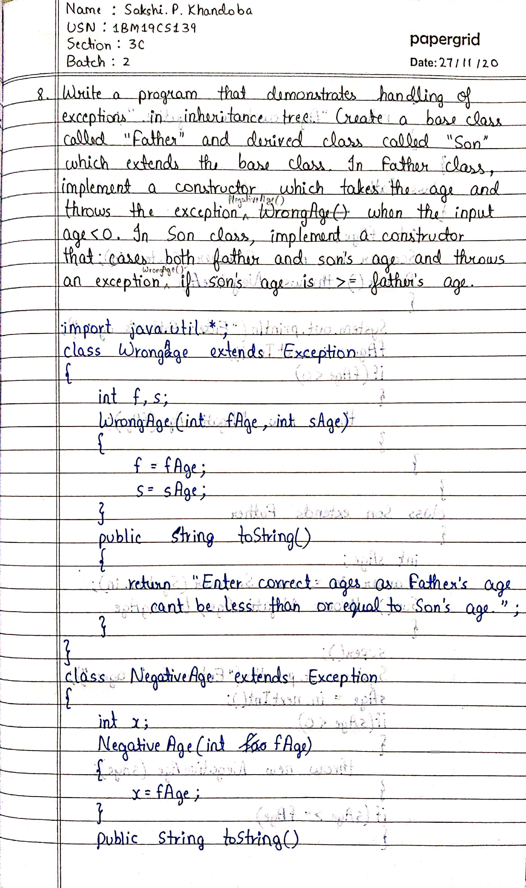

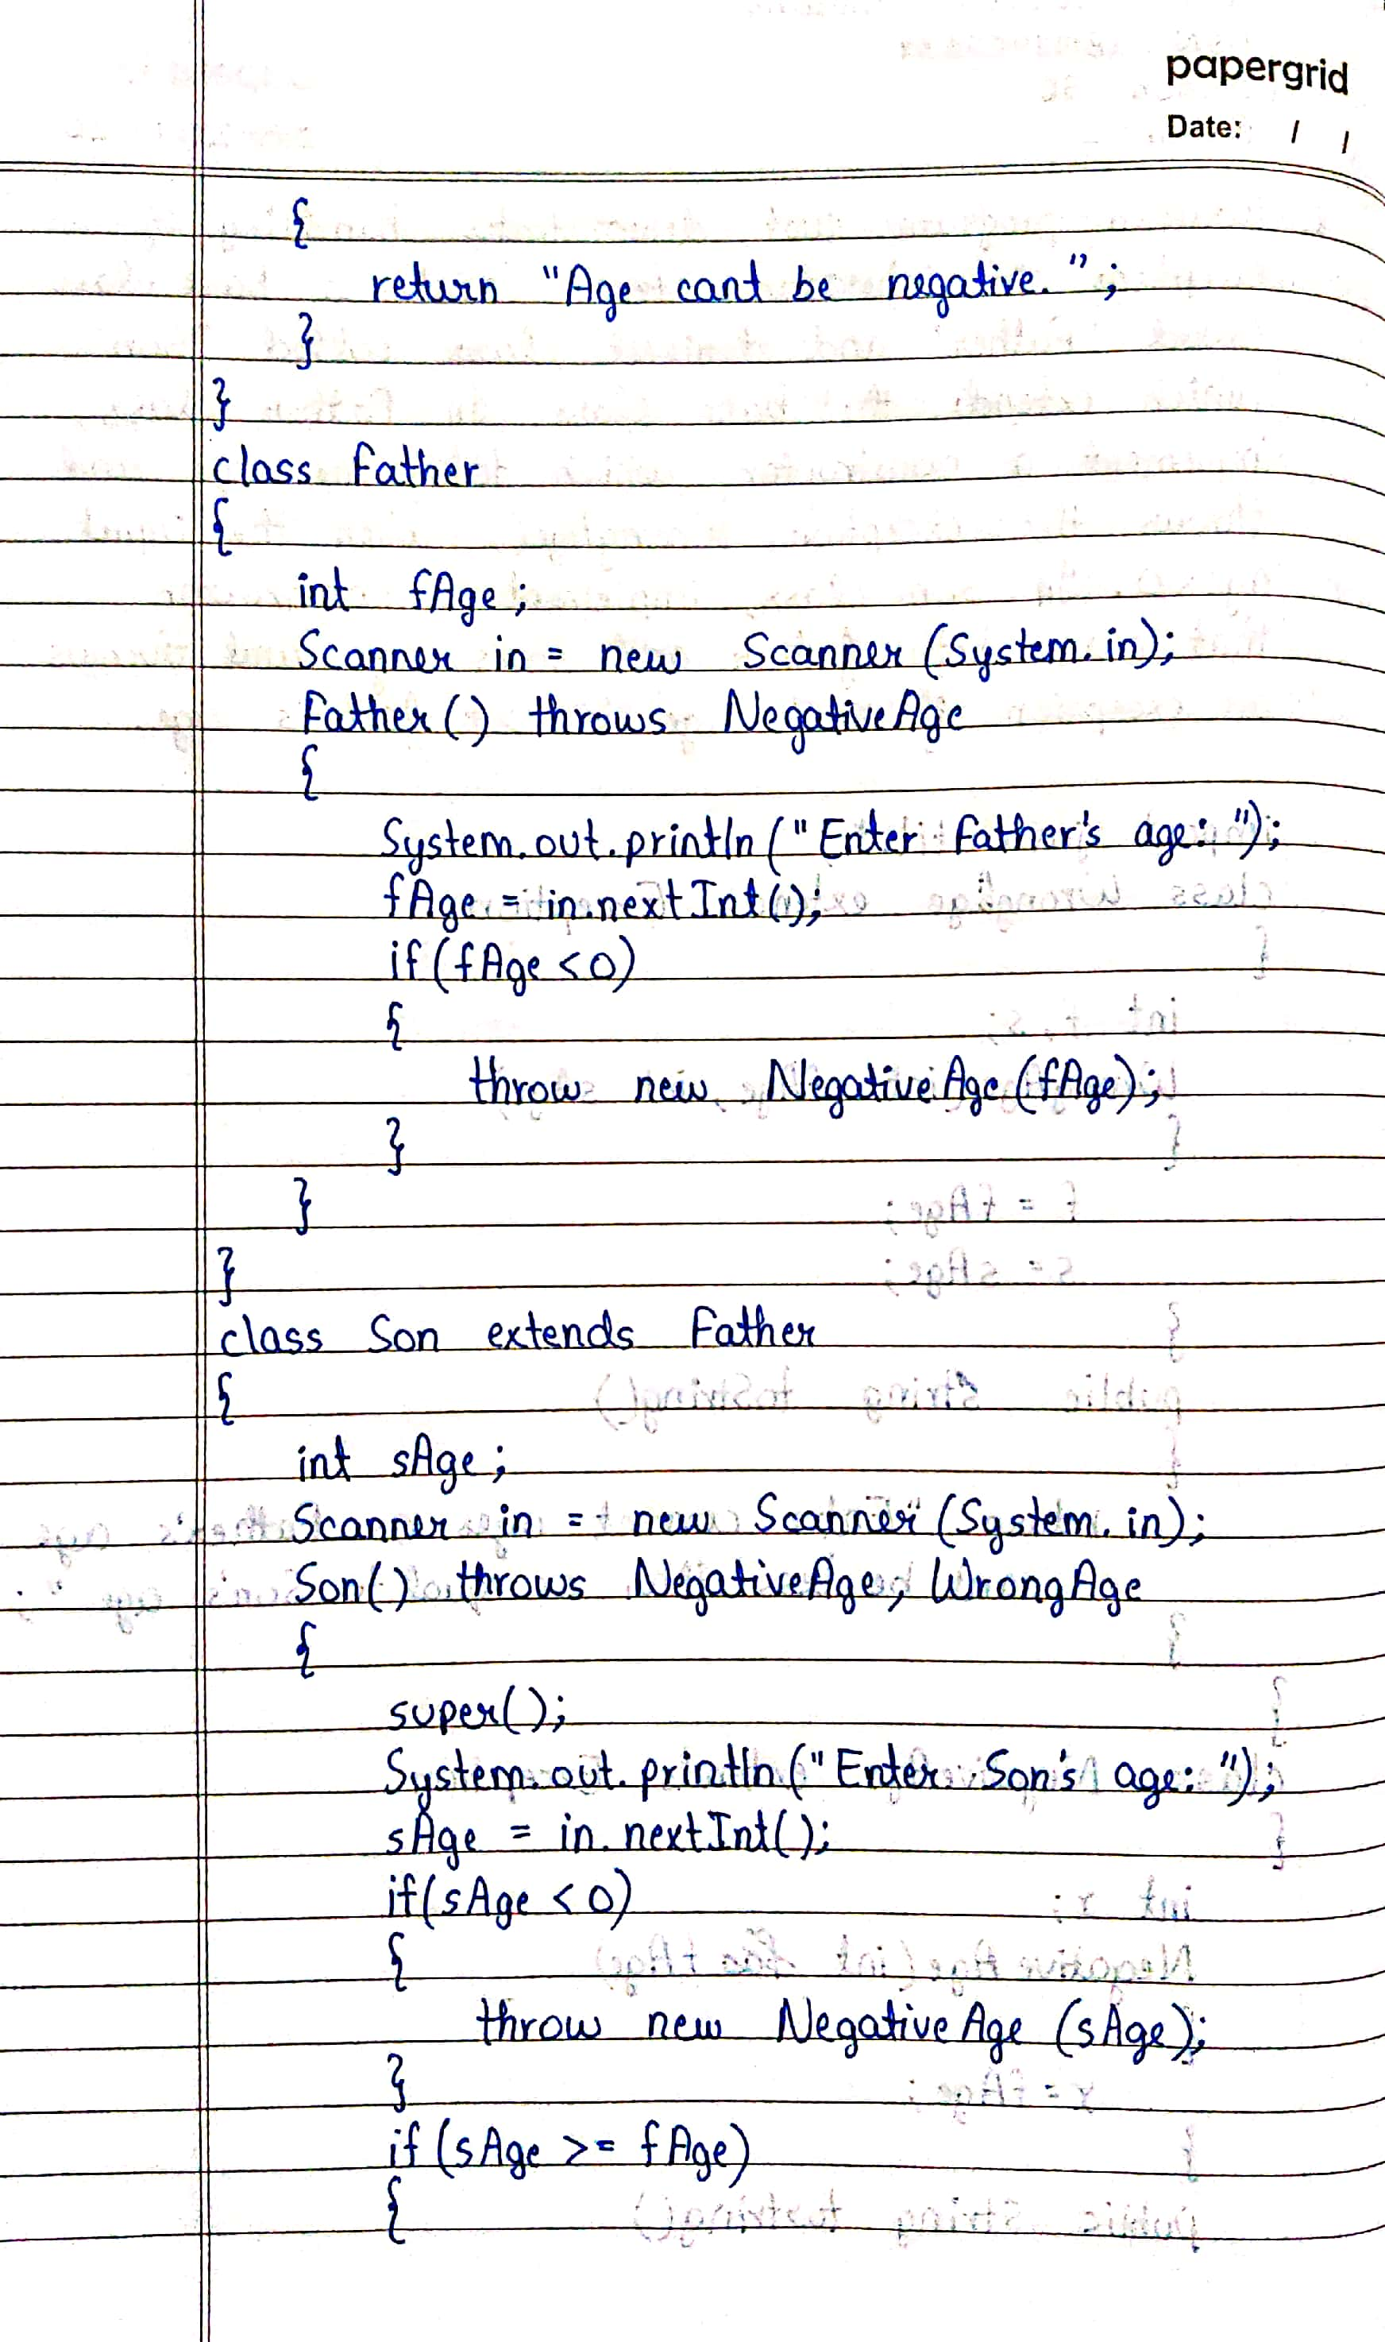

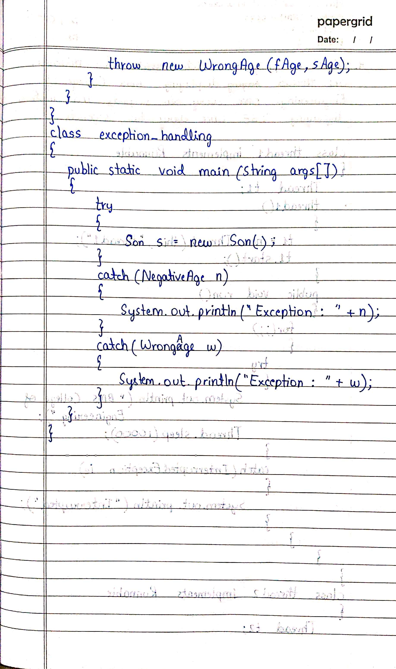

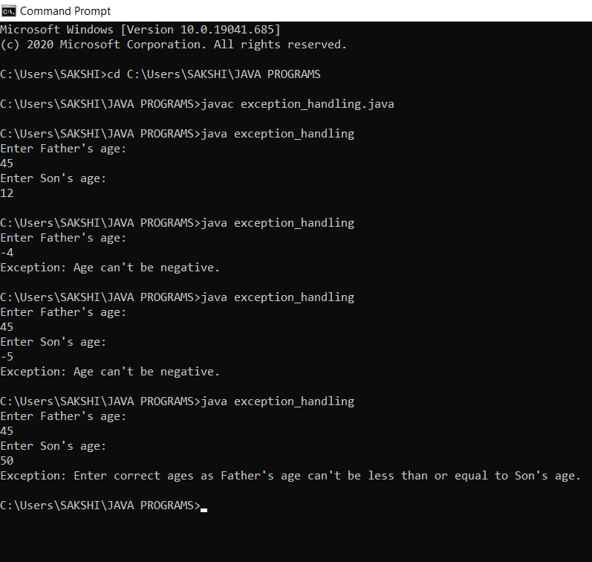

**LAB PROGRAM 9**

**Write a program which creates two threads, one thread displaying “BMS College of Engineering” once every ten seconds and another displaying “CSE” once every two seconds.**

class thread1 implements Runnable

{

Thread t1;

thread1()

{

t1 = new Thread(this,"thread1");

t1.start();

}

public void run()

{

for(;;)

{

try

{

System.out.println("BMS College Of Engineering");

Thread.sleep(10000);

}

catch(InterruptedException ie)

{

System.out.println("Interrupted");

}

}

}

}

class thread2 implements Runnable

{

Thread t2;

thread2()

{

t2 = new Thread(this,"thread2");

t2.start();

}

public void run()

{

for(;;)

{

try

{

System.out.println("CSE");

Thread.sleep(2000);

}

catch(InterruptedException ie)

{

System.out.println("Interrupted");

}

}

}

}

class threads

{

public static void main(String args[])

{

System.out.println("Enter CTRL+C to stop");

thread1 t1 = new thread1();

thread2 t2 = new thread2();

}

}

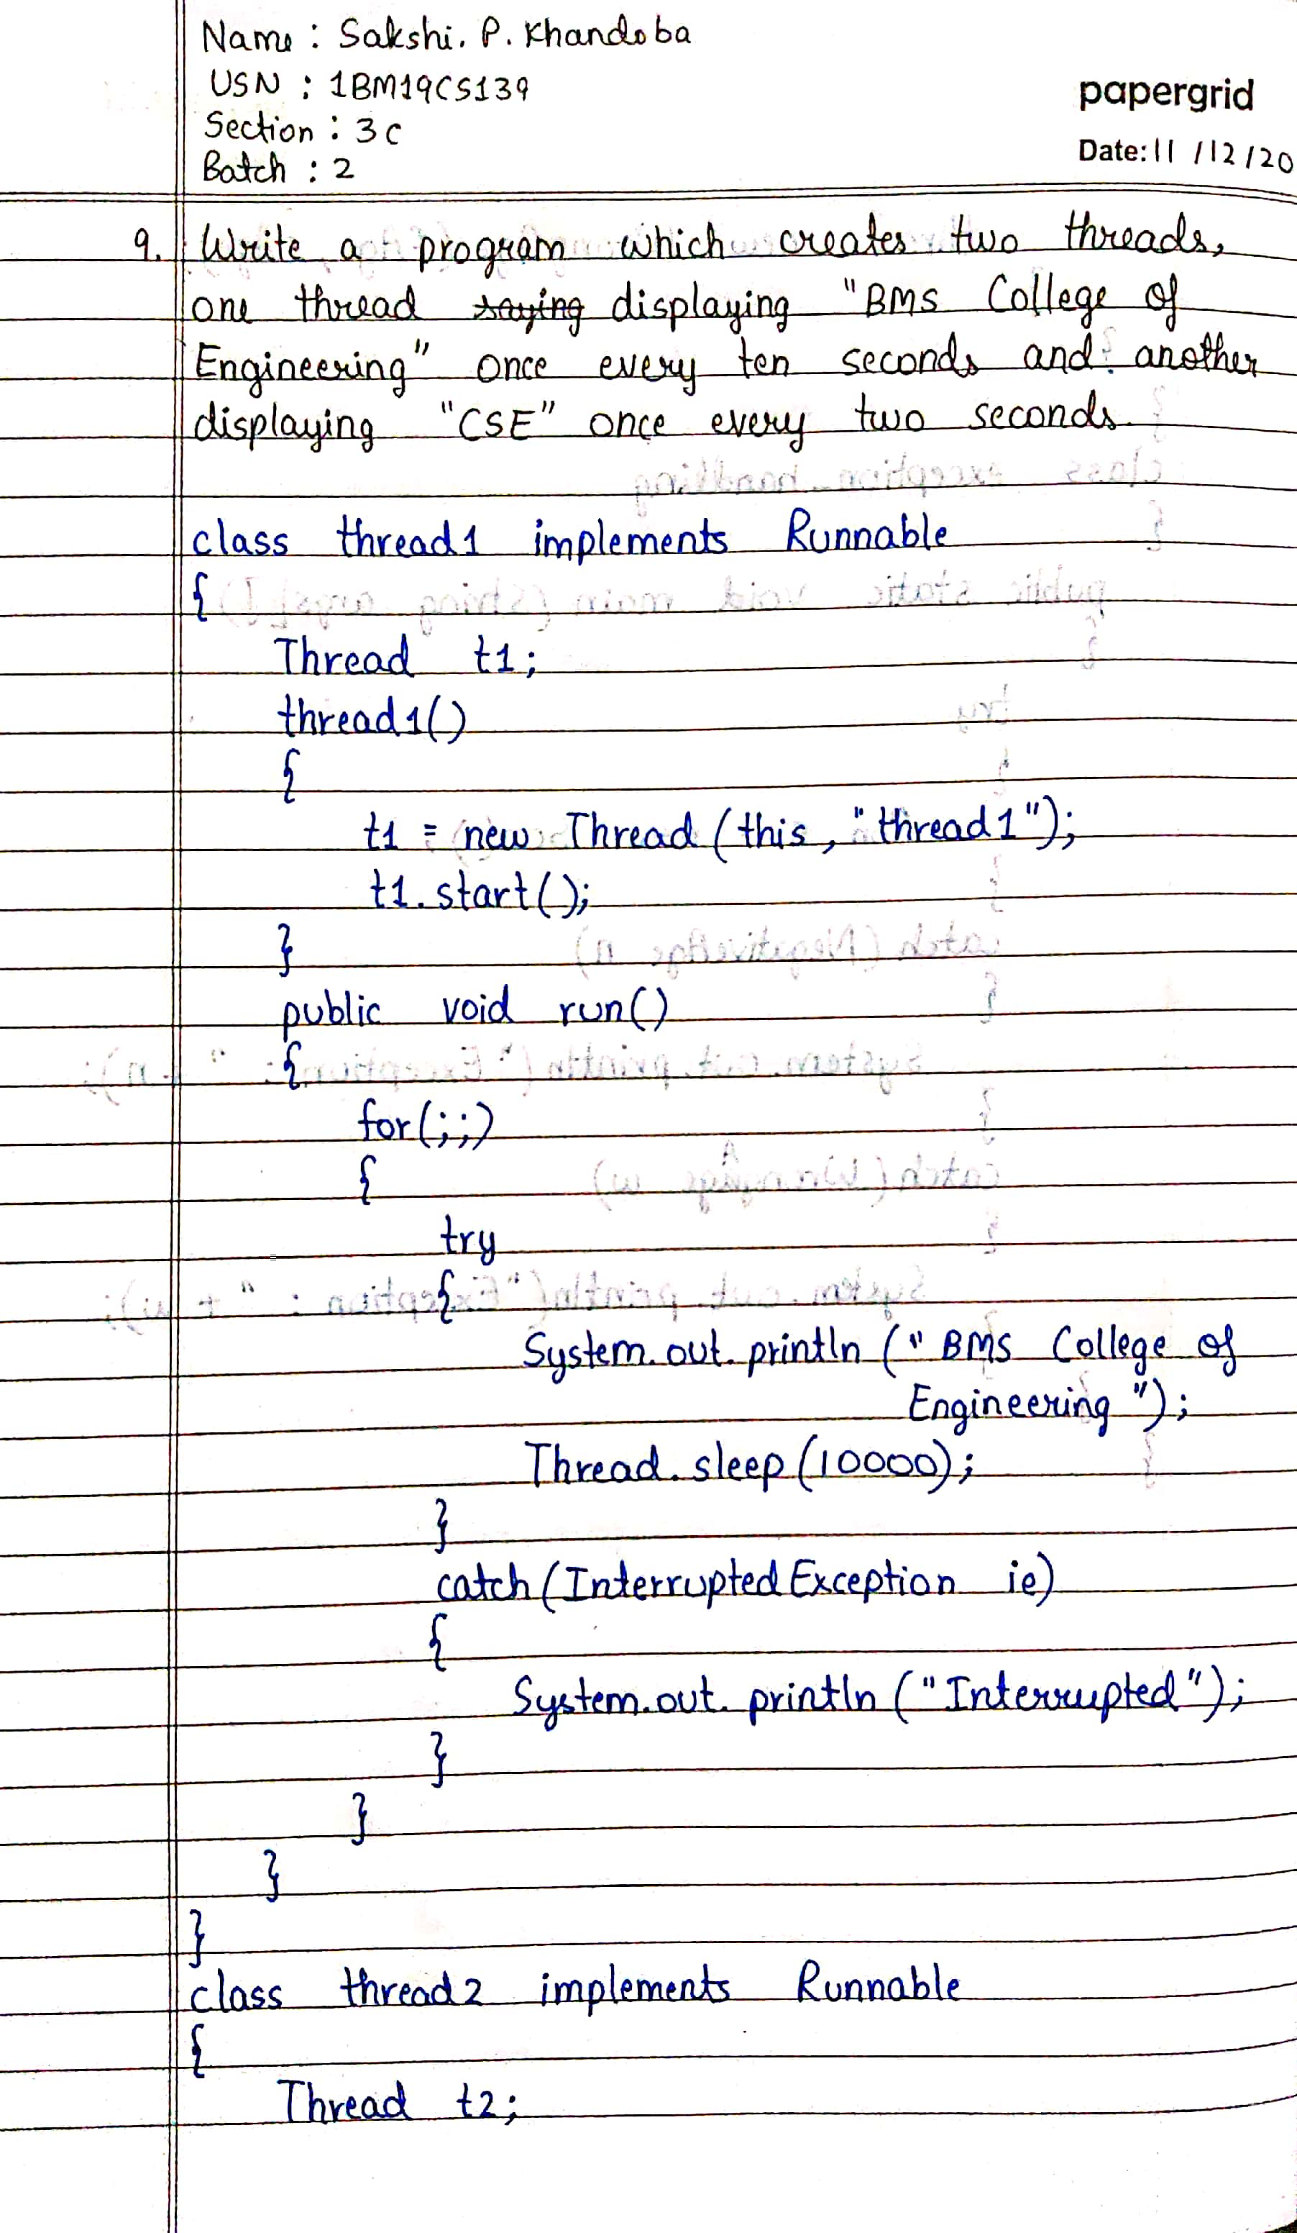

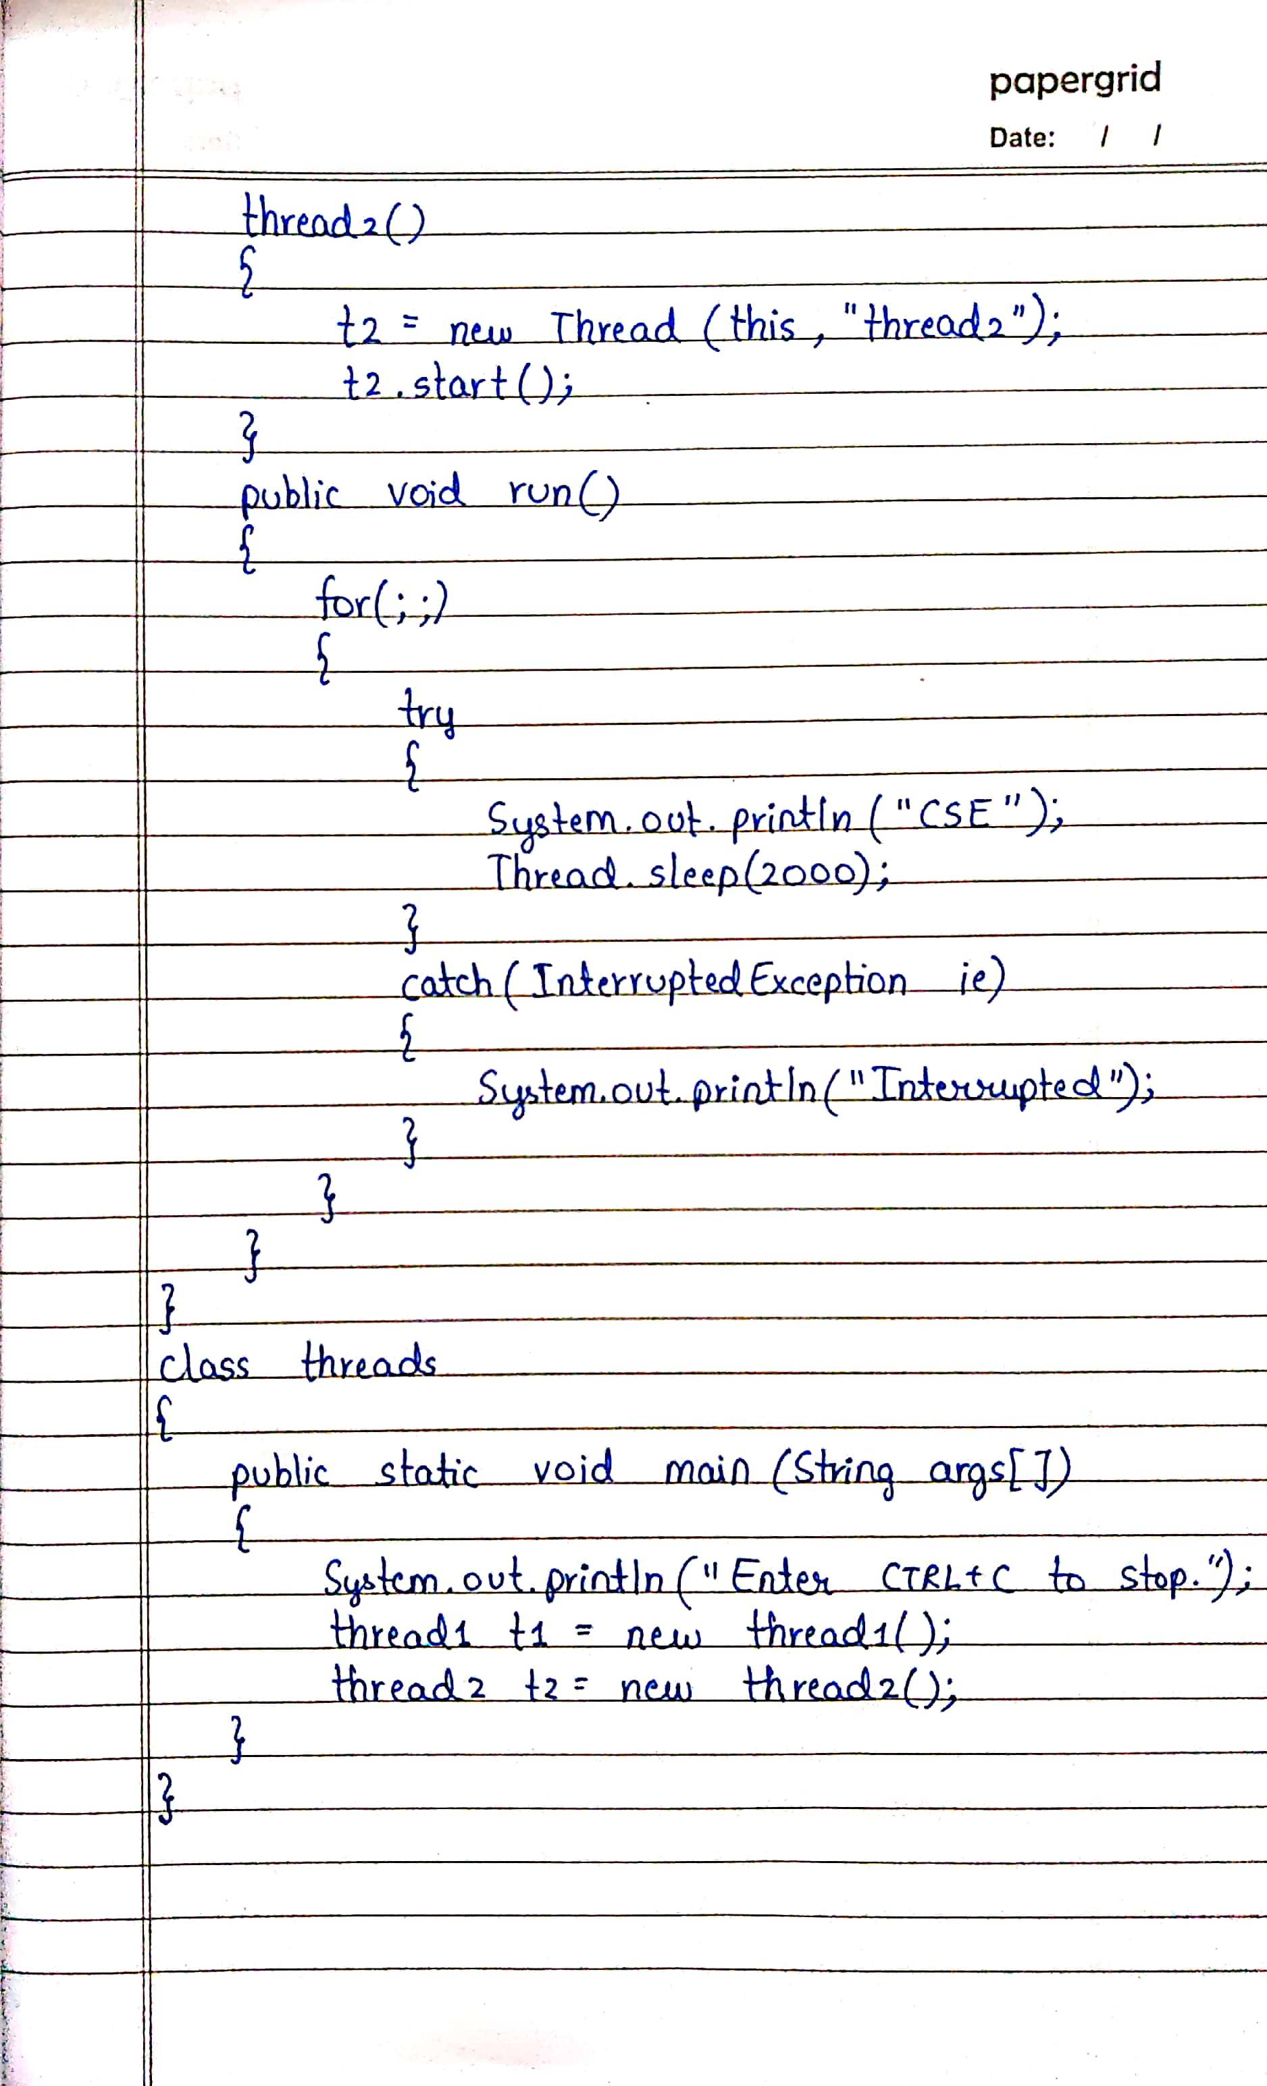

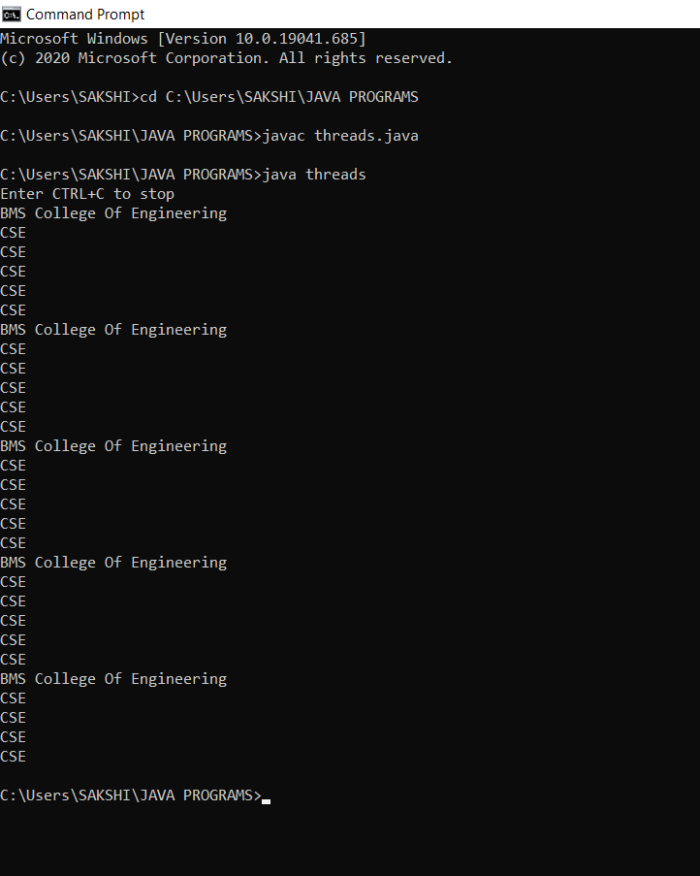

**LAB PROGRAM 10**

**Write a program that creates a user interface to perform integer divisions. The user enters two numbers in the text fields, Num1 and Num2. The division of Num1 and Num2 is displayed in the Result field when the Divide button is clicked. If Num1 or Num2 were not an integer, the program would throw a NumberFormatException. If Num2 were Zero, the program would throw an ArithmeticException. Display the exception in a message dialog box.**

import java.awt.*;

import java.awt.event.*;

import javax.swing.*;

public class division extends Frame implements ActionListener{

TextField n1,n2,res;

Label ln1,ln2,lres;

Button b;

public division(){

setLayout(new FlowLayout());

Label ln1=new Label("NUMBER 1",Label.RIGHT);

Label ln2=new Label("NUMBER 2",Label.RIGHT);

Label lres=new Label("RESULT",Label.RIGHT);

n1=new TextField(12);

n2=new TextField(8);

res=new TextField(10);

b=new Button("DIVIDE");

add(ln1);

add(n1);

add(ln2);

add(n2);

add(b);

add(lres);

add(res);

b.addActionListener(this);

addWindowListener(new WindowAdapter1());

}

public void actionPerformed(ActionEvent ae)

{

if(ae.getSource()==b)

{

try{

int num1=Integer.parseInt(n1.getText());

int num2=Integer.parseInt(n2.getText());

int num3=num1/num2;

res.setText(String.valueOf(num3));

}catch(NumberFormatException ne ){

JOptionPane.showMessageDialog(this,ne,"ERROR", JOptionPane.ERROR_MESSAGE);

}

catch(ArithmeticException a){

JOptionPane.showMessageDialog(this,a,"ERROR", JOptionPane.ERROR_MESSAGE);

}

}

}

public static void main(String args[])

{

division i=new division();

i.setSize(new Dimension(700,300));

i.setTitle("DIVISION OF TWO INTEGERS");

i.setVisible(true);

}

class WindowAdapter1 extends WindowAdapter{

public void windowClosing(WindowEvent we)

{

System.exit(0);

}

}

}

